Lab 11: Investigating browser history
What You Need for this lab
  - Install Virtualbox : https://www.virtualbox.org/wiki/Downloads
  - Install Kali 2021.4. : https://old.kali.org/kali-images/kali-2021.4/
    - Notes: Suggest You configure the disk size of Kali VM 80G because the size of each leakage cases image is 30G+
  - Image “cfreds_2015_data_leakage_pc.dd” from Lab 5
Goals
- Understand the application layer of a computer system that generates evidence
- Understand the behavioral model of an application
- The approach to investigating browser history (evidence generated by an application)
- Familiar with important tools for browser investigations
Step 1
- Set up loop device (a pseudo-device that makes a file accessible as a block device)
losetup --partscan --find --show --read-only cfreds_2015_data_leakage_pc.dd
mkdir /mnt/loopdev
mount -o ro,loop,offset=206848 cfreds_2015_data_leakage_pc.dd /mnt/loopdev
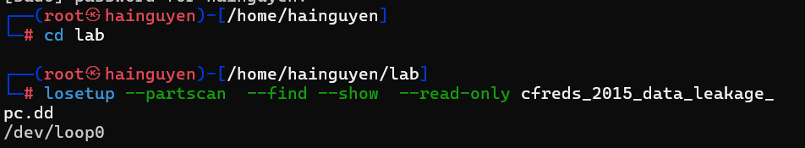
- Check all versions of IE via .log
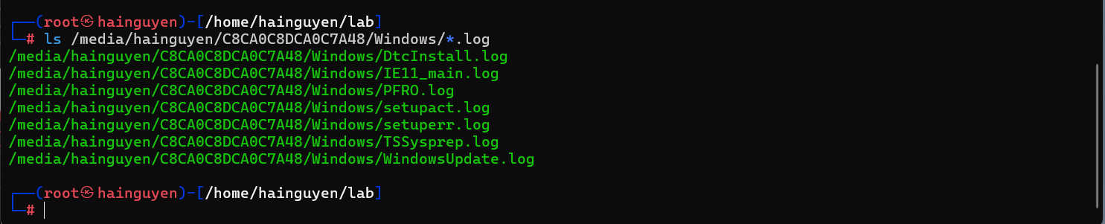

- Exam IE logs
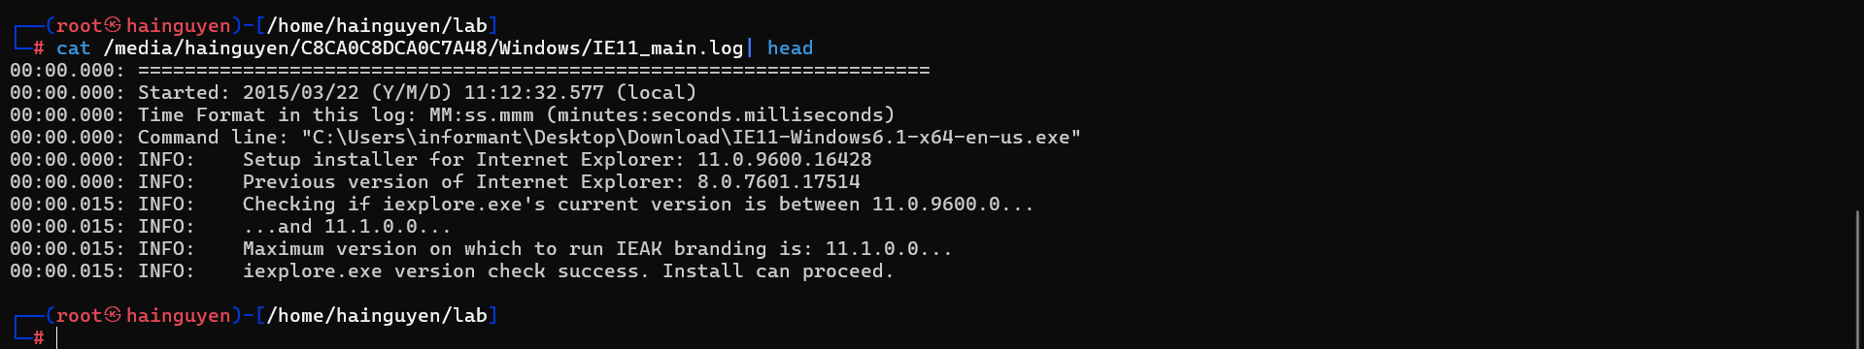
- Can you find the version number?
Use Windows Registry hive shell (hivexsh)
- Install hivexsh
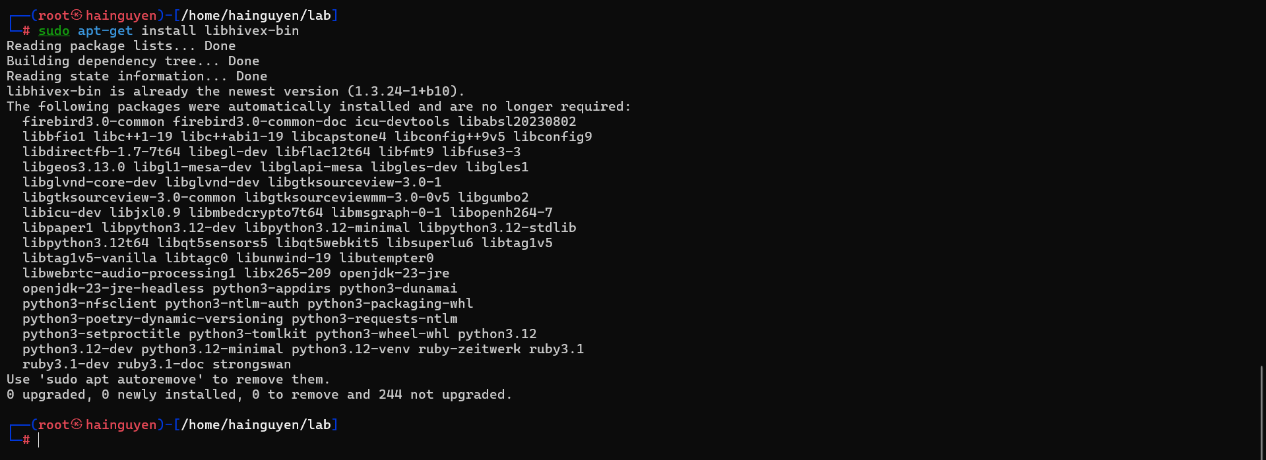
- Exam the version of IE using hivexsh
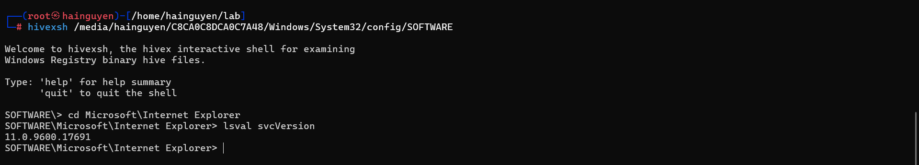
Step 2.
Identify directory/file paths related to the web browser history
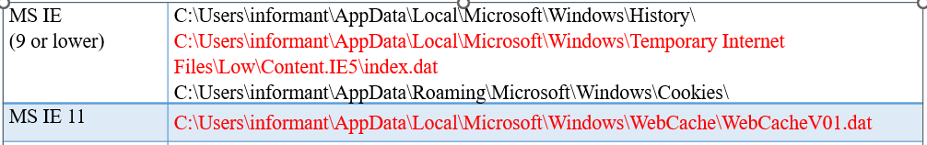

- Internet Explorer 11 History
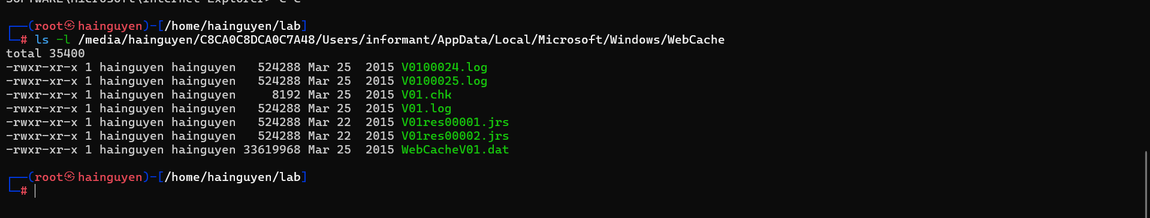
- Find Google Chrome Cache, Cookies, and History
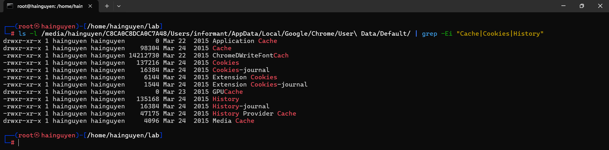
What websites were the suspect accessing? (Timestamp, URL...)
  - Get browser history files
  - View these files
Step 1.
Copy Three Browser History Files
Copy IE 11 History
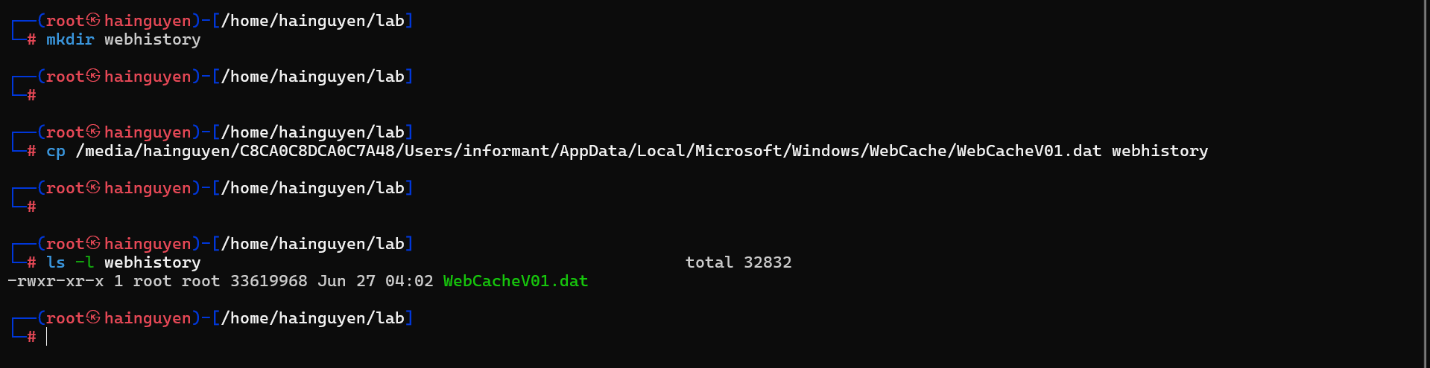
Copy IE 8 History
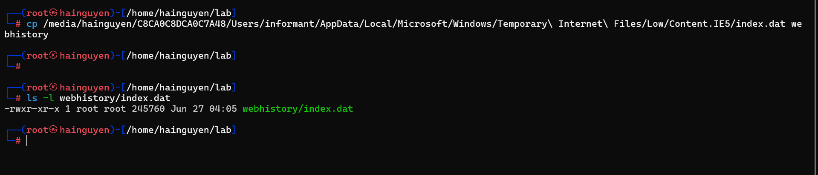

Copy Chrome History
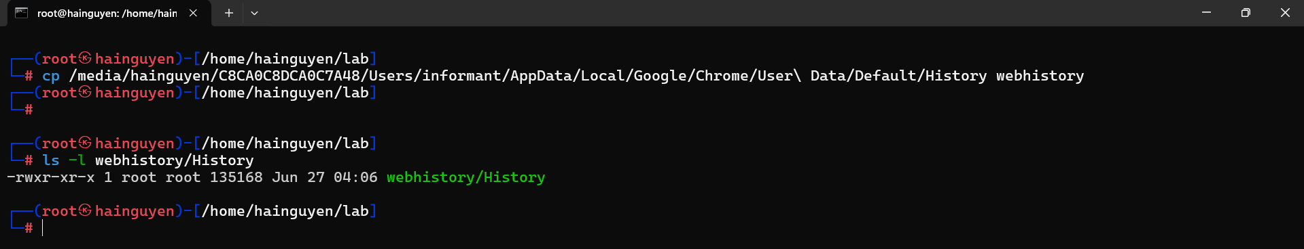
Step 2.
View IE 11 History Using libesedb
Find the file type of WebCacheV01.dat
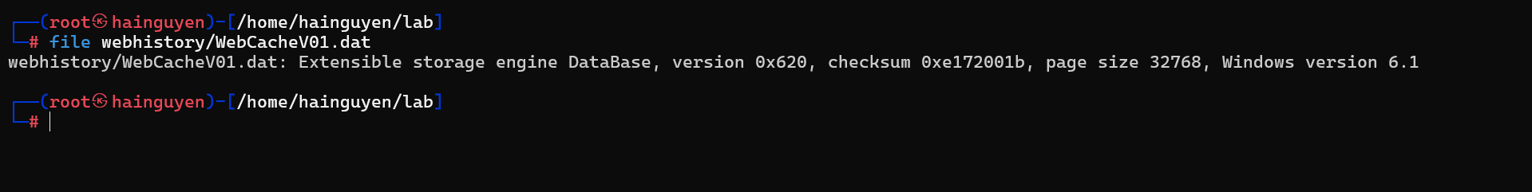
- Install libesedb
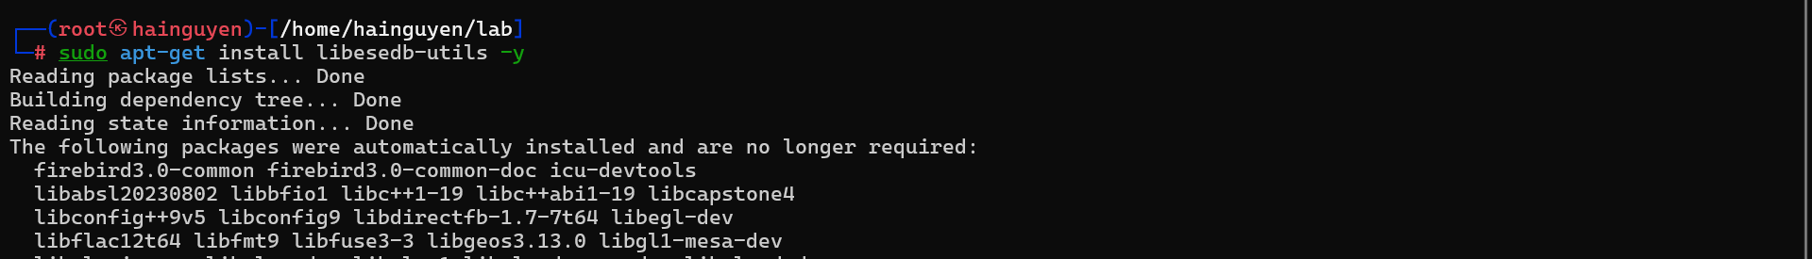
- Export WebCacheV01.dat to the folder webhistory/IE11
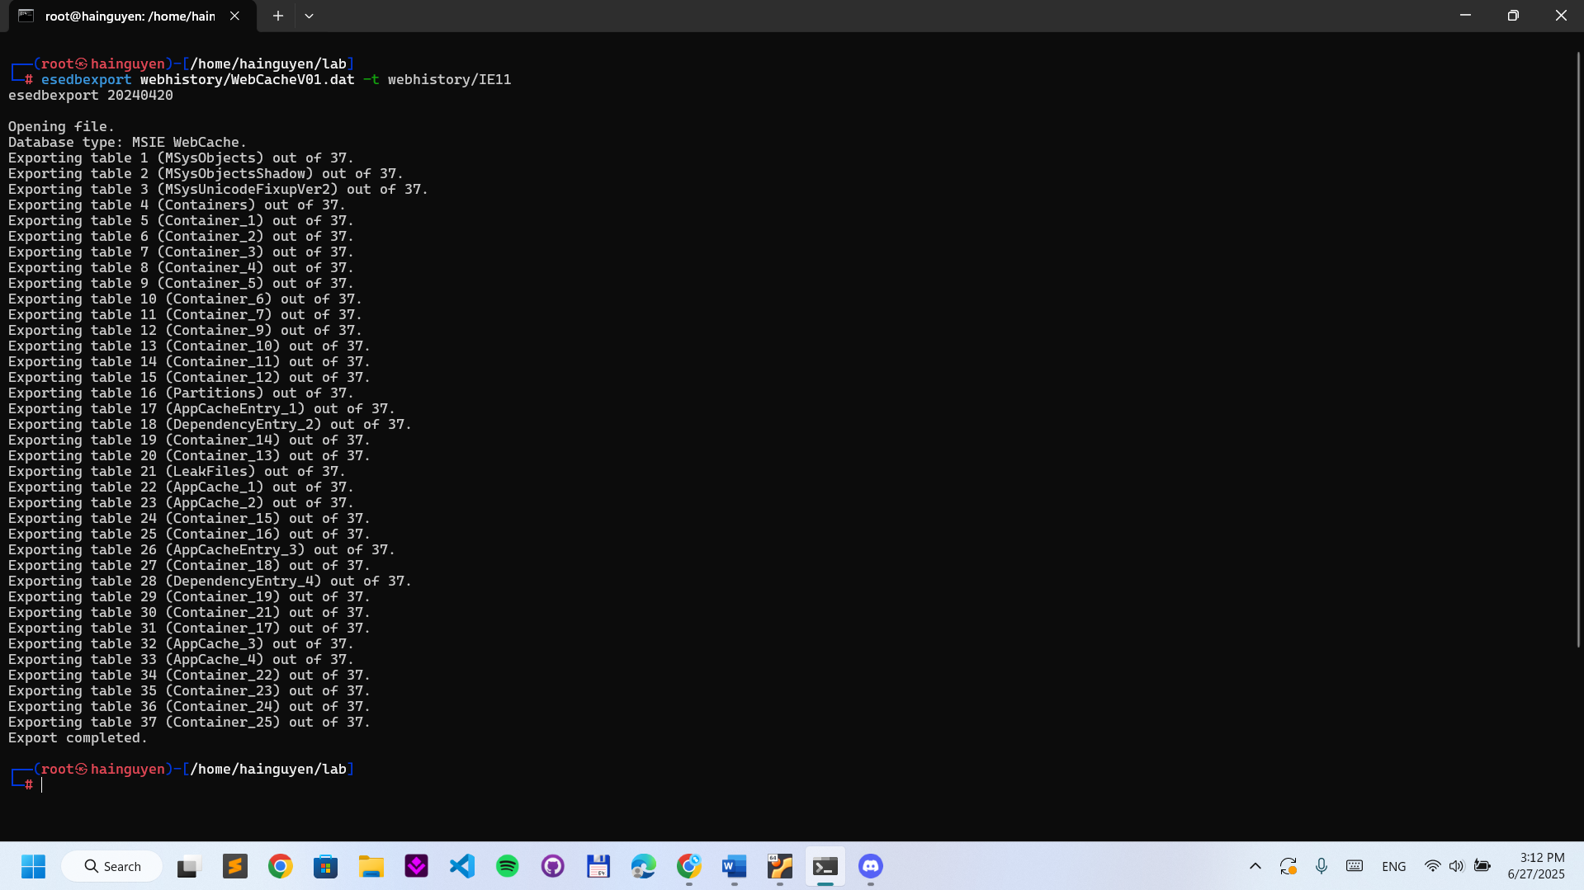

- Find the type of the file
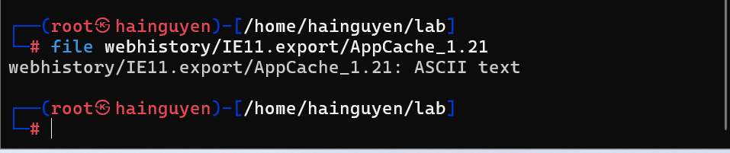
- Create three lines with three attributes
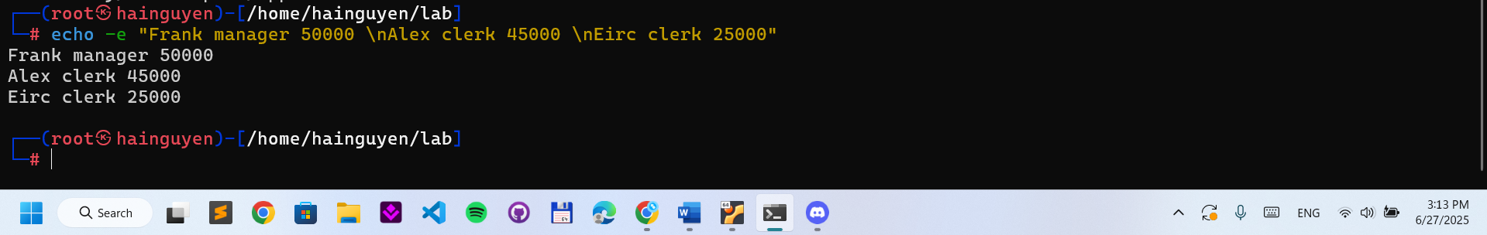
- Select lines with the key word “manager”
- Select attributes 1 and 3
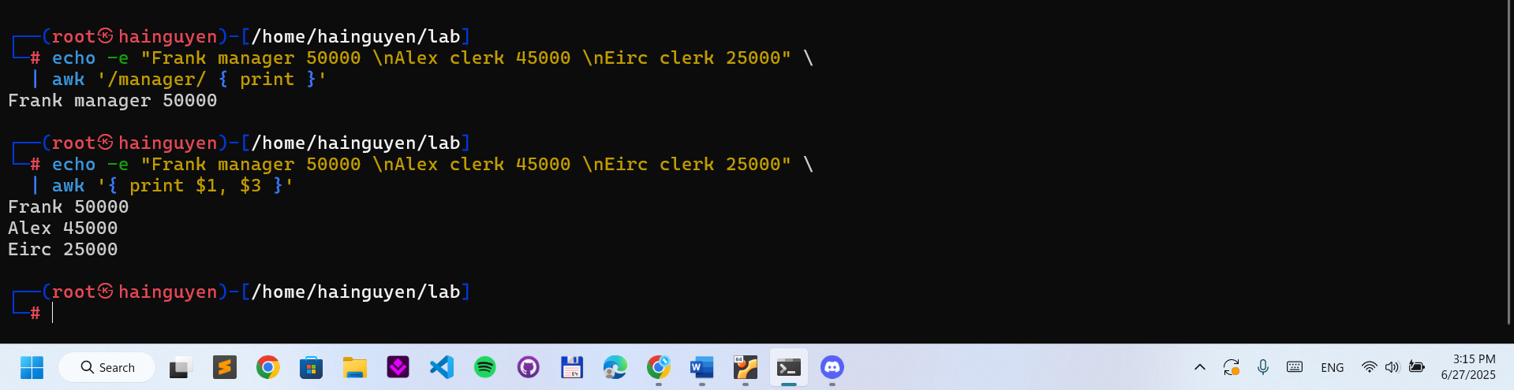
- Show Row Number
echo -e "Frank manager 50000 \nAlex clerk 45000 \nEirc clerk 25000" | awk '{print NR, $1}‘
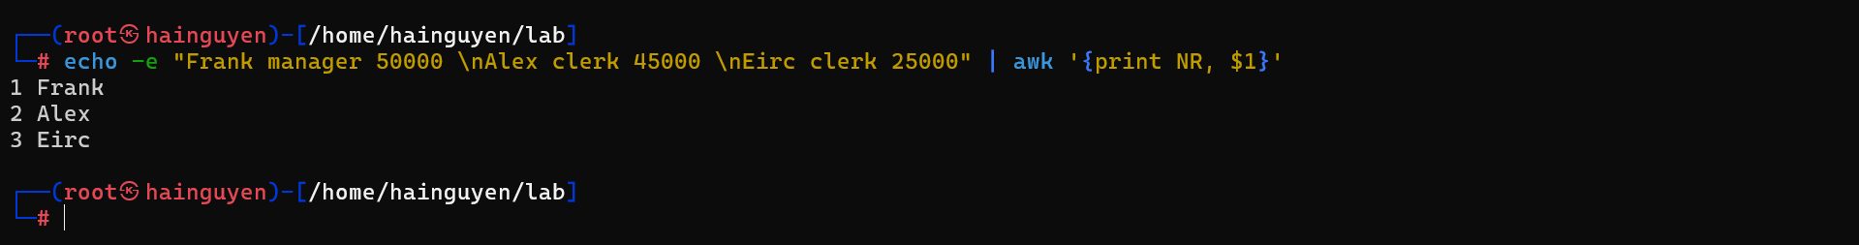
- Calculate sum
echo -e "Frank manager 50000 \nAlex clerk 45000 \nEirc clerk 25000" | awk '{sum +=$3} ; END {print sum}'
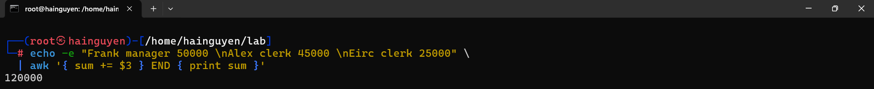
- Show field names
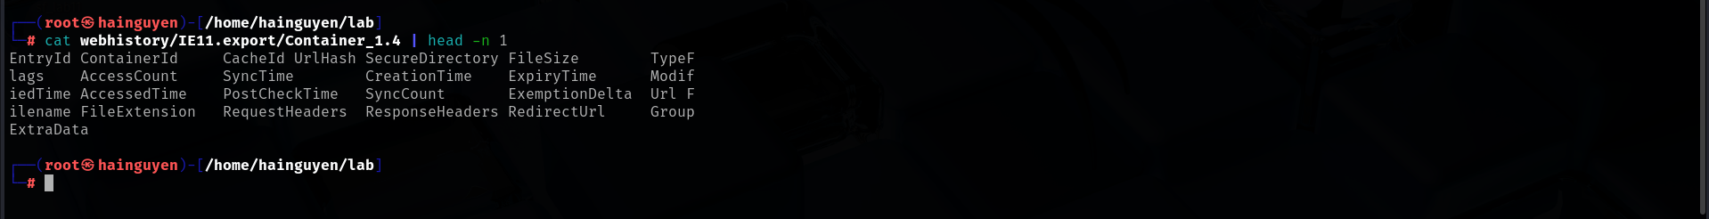
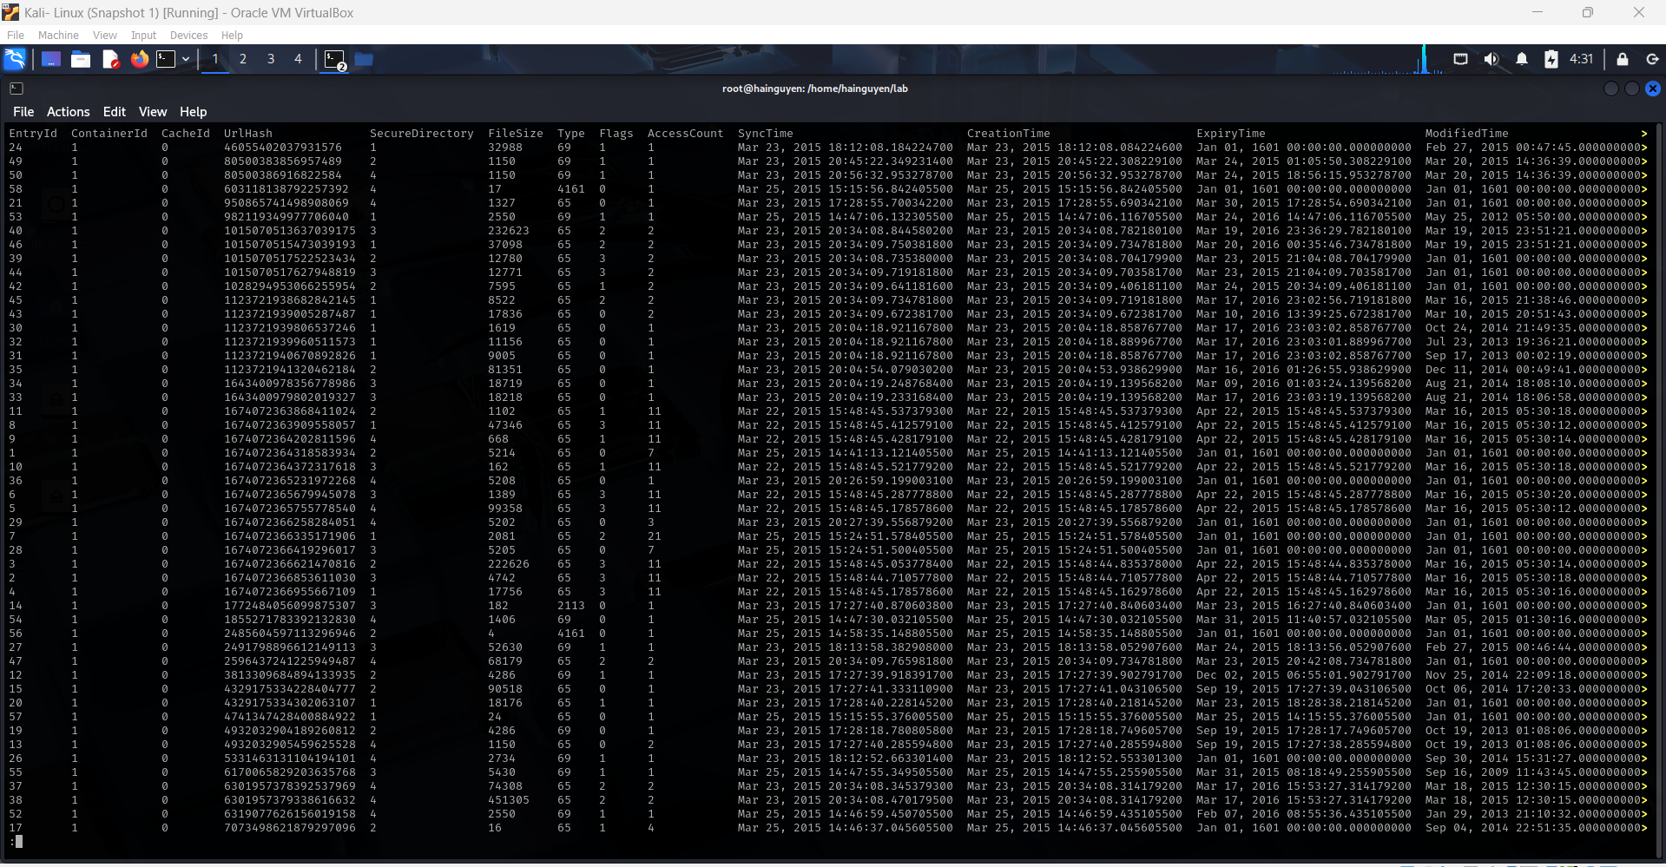
- Separate fields with tab ‘\t’ and show ModifiedTime and URL
awk '{print NR, $13, $18}' FS='\t' webhistory/IE11.export/Container_1.4 | head -n 5
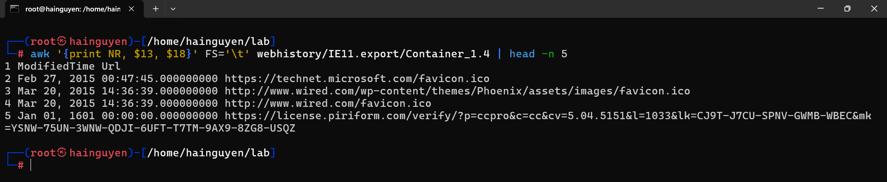
- Count the number records in the file
awk '{print NR, $13, $18}' FS='\t' webhistory/IE11.export/Container_1.4 | wc –l
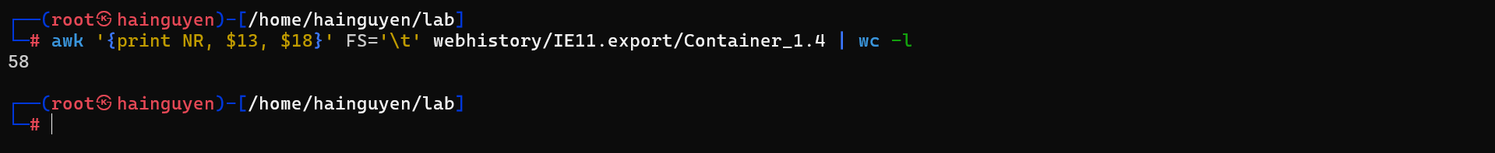
- Count the number records in all files start with the string “Container”
awk '{print NR, $13, $18}' FS='\t' webhistory/IE11.export/Container* | wc -l
Step 3.
List all search keywords using web browsers. (Timestamp, URL, keyword...)
- IE browser
Web Query String
https://www.bing.com/search?q=myteststring&src=IE-SearchBox&FORM=IEMAE2&pc=EUPP
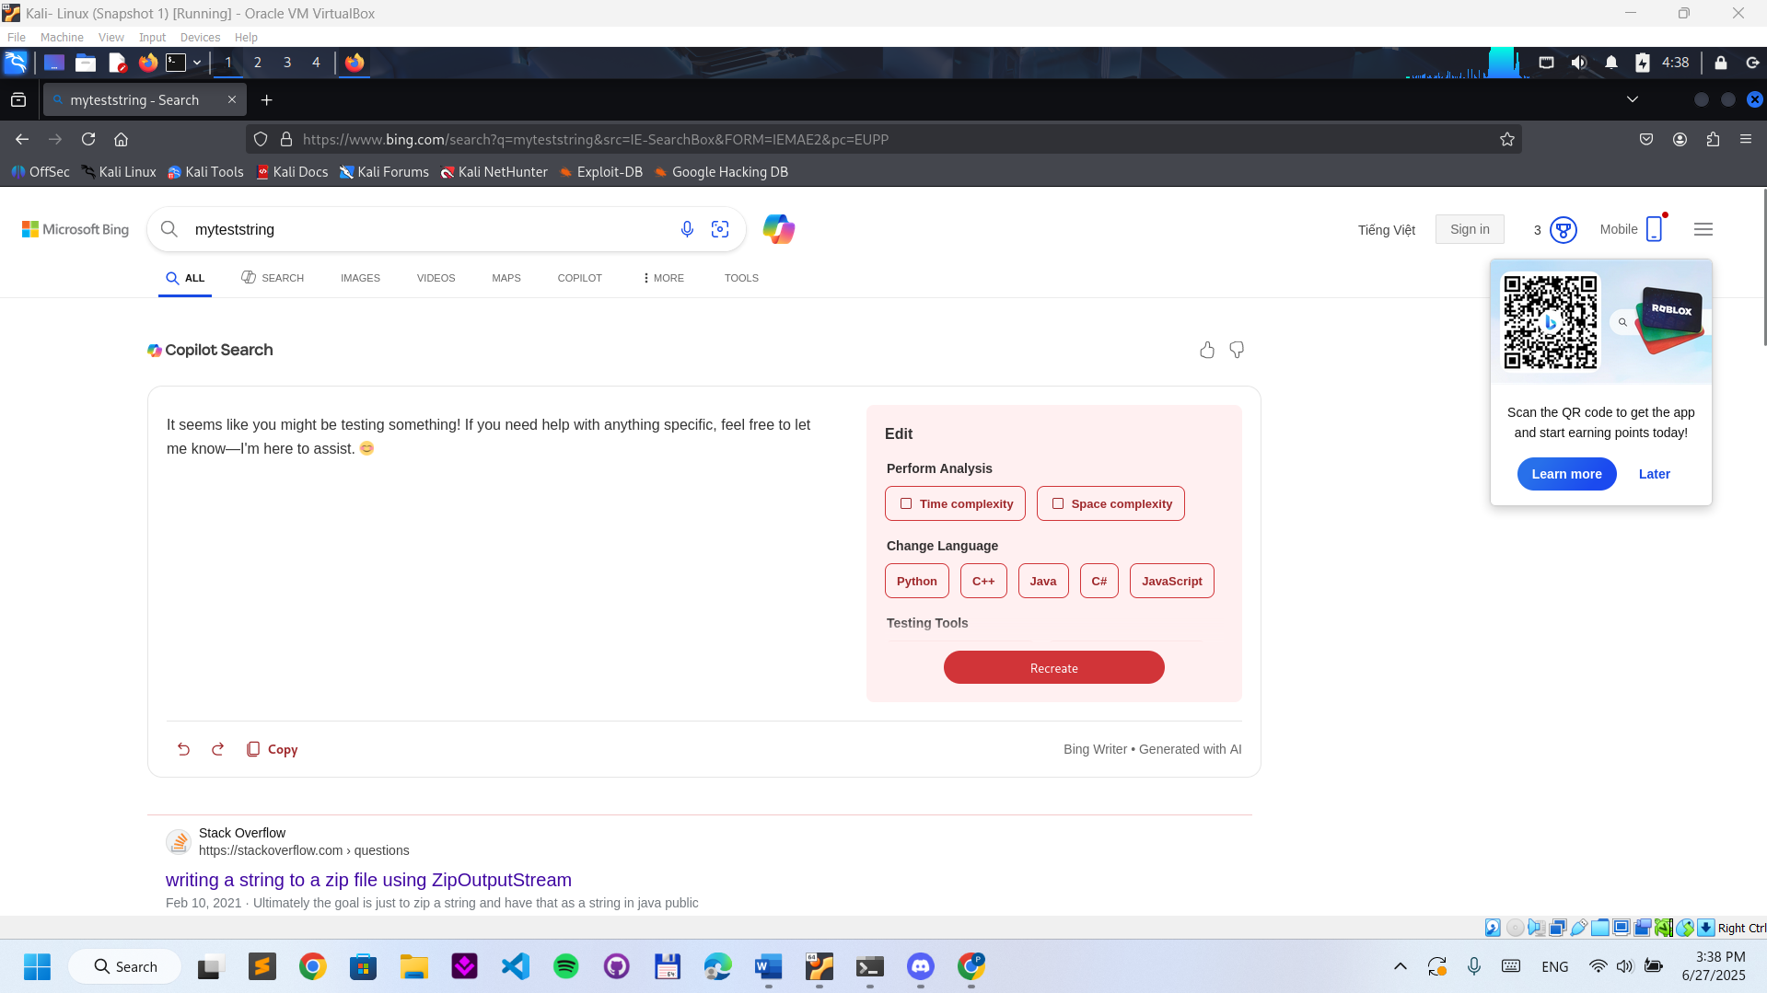
- Regular expression for bing.com search
https://regexr.com/
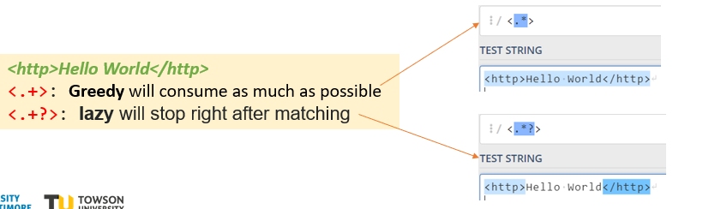
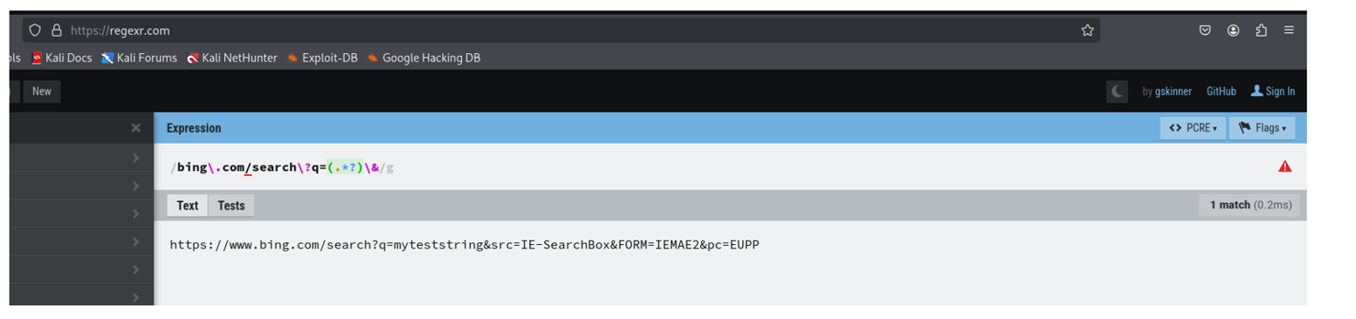
- List IE 11 search keywords
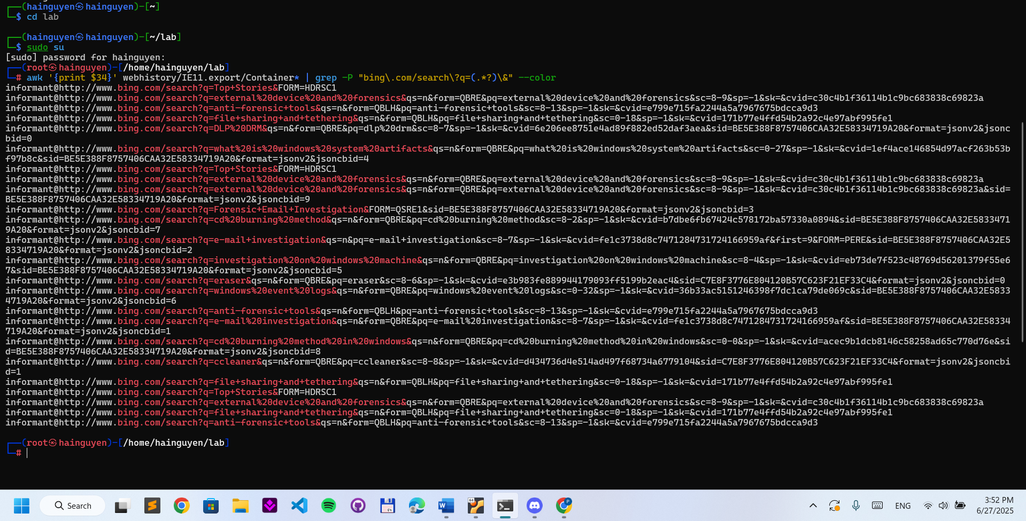

YOU MUST SUBMIT A FULL-SCREEN IMAGE FOR FULL CREDIT!
Save the document with the filename "YOUR NAME Lab 11.pdf", replacing "YOUR NAME" with your real name.
Email the image to the instructor as an attachment to an e-mail message. Send it to: xxx@fe.edu.vn with a subject line of "Lab 11 From YOUR NAME", replacing "YOUR NAME" with your real name.

